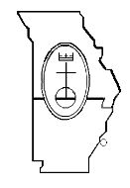
The 2019 Conference Annual Gathering (CAG) will once again be held at the Holiday Inn Executive Center in Columbia, MO, June 6-8. Below are the Standing Rules and Rules for the Introduction of New Business that have been approved by the MMS Conference Council. Please reference these if you have any new business that you would like us to consider in June.
Please review the documents explaining the procedures and deadline dates:
- Rules for Introduction of New Business at CAG
- Standing Rules for CAG

