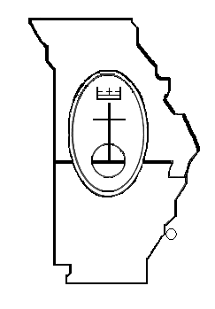
Missouri Mid-South Conference United Church of Christ
Rev. Dr. Ginny Brown Daniel-483 E Lockwood Ave. Ste. 15, St. Louis, MO 63119
Phone 314-918-2604 Fax 314-918-2610 Toll Free 877.877.5884

Uniting Congregations for Ministry and Mission in Missouri, Arkansas, and Memphis, Tennessee
www.missourimidsouth.org

Conference Annual Gathering 2020
April 24 and 25, 2020

Friday, April 24 The Oasis, UCC (2017 William Street Jefferson City, MO 65109)
9:00 am – 4:00 pm Boundary Awareness Training Event
11:00 am CAG planning team arrives at the Oasis, UCC/Central, UCC
1:00 – 4:00 pm Conference Council Meeting at the Oasis, UCC
5:00 - 6:30 pm Meet Associate Conference Minister candidate with Supper at the Oasis, UCC
6:30 – 7:00 pm Prepare for Opening Worship
7:00 - 8:30 pm Worship with Associate Conference Minister at the Oasis, UCC

Saturday, April 25 Central, UCC (118 W Ashley Jefferson City, MO 65101-2904)
8:00 am Vendor set up and Registration begins at Central, UCC
9: 00 - 9:15 am Opening Devotional by MMS Youth
9:15 -11:45 am Business Session I
- Speak Outs
- Call to Order
- Credentials Report
- Adoption of the Agenda and Standing Rules
- Adoption of the Introduction the New Business
- Opening Prayer
- Review and Approval of the 2019 Conference Annual Gathering minutes
- Introduction and Acknowledgement of Guests
- Conference Minister and Staff Reports
- Treasurer’s Report – Budget 2021 delayed approval
- Vote on sale of Camp MoVal southern property
- Recess with closing prayer
11:45 am-1:00 pm Lunch
1:00 - 2:30 pm Business Session II
- Speak Outs
- Call to Order
- Report from Leadership and Development on Nominations
- Vote on Unifying Call and Core Ministries
- Associate Conference Minister (ACM) Search Committee Report
- Introduction of the ACM
- Vote to Call the Associate Conference Minister
- Recognition of Departing MMS Staff and Conference Council Members
- Announcements and Thanks
2:30 – 2:45 pm Break to Prepare for Closing Worship
2:45 – 4:00 pm Closing Worship to Include Celebration of Churches and Ministers with Anniversaries and Installation of Conference Leaders

