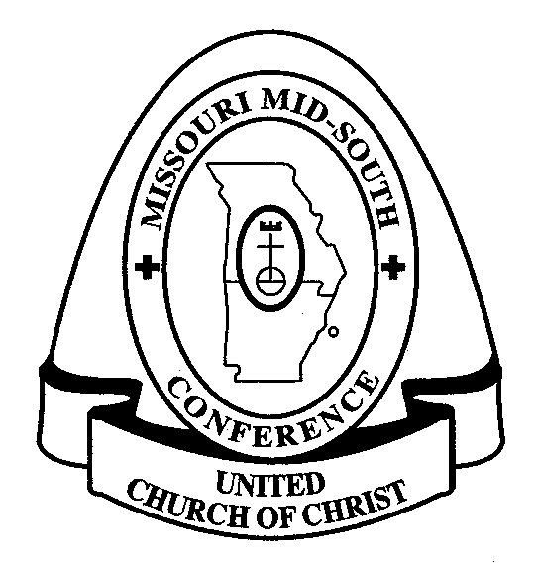
Western Association
Missouri Mid-South Conference
United Church of Christ

Western Association Annual Meeting
via Zoom

“The Church in These New Times”
October 23, 2021

Dear Members of the Western Association,

Our Annual Meeting will be held via Zoom on Saturday, October 23, 2021. The agenda for this meeting is included in this email.

Please register for this meeting using this link:
https://zoom.us/meeting/register/tJwrfuyhqD8vEtY-5NTsqL78H1Vi_jnoYBKn

All reports are available on the Western Association page of the Missouri Mid-South website.
https://www.missourimidsouth.org/western-association

You’ll notice that we are looking for one more nominee to serve on the Committee on Ministry. This should be a layperson. COM members are elected for a 3-year term. Meetings are conducted on Zoom and are held during the day. If you or anyone you know might be interested in serving, please contact Moderator Ron Wendle (rwendle@sbcglobal.net).

Grace and peace,

Rev. Jeanne Lischer, Vice Moderator

Western Association
Missouri Mid-South Conference
United Church of Christ

Western Association Annual Meeting
via Zoom

“The Church in These New Times”
October 23, 2021

AGENDA

9:30 am Roll Call of Churches Juanita Wright, Secretary

9:45 am Call to Order, Welcome, & Introductions Ron Wendle, Moderator

Devotion Rev. Karen Aitkens

10:00 am Business Meeting

Approval of Agenda and the Moderator’s Report Ron Wendle, Moderator

Minutes of 2020 Annual Meeting Juanita Wright, Secretary

Committee on Ministry Report Linda Stenger, COM Chair

Treasurer’s Report & 2022 Budget Stephen Price, Treasurer

Nominating Committee Report Rev. Jeanne Lischer, Vice Moderator

Proposed Bylaw Change Ron Wendle, Moderator

10:45 am Conference Report Rev. Mary Nelson, Transitional Conference Minister

11:00 am Break

11:10 am Announcements Ron Wendle, Moderator
Speak Outs Ron Wendle, Moderator
Introduction of Members in Discernment Linda Stenger, COM Chair

11:30 am Keynote Rev. Mary Nelson, Transitional Conference Minister

Noon Break out “rooms” for each cluster
Reports from each cluster

12:20 pm Closing Worship Rev. Jeanne Lischer, Vice Moderator
with Installation of newly elected Association Officers, Council Members, Committee on Ministry Members

12:45 pm Adjourn

