Friedens UCC Moscow Mills
Celebrating 150 Years
1871 – 2021

In the early sixties of the nineteenth century Evangelical pioneers began to settle in the area between now the town of Moscow Mills and Eagle Fork. The location of Eagle Fork is marked today by Eagle Fork Farm owned by the Meyer family.

These immigrants had come from pious German families and as soon as they had established their homes their thoughts turned to establishing a church—but where? They made contact with St. Paul’s Church, Old Monroe, which had an ordained pastor and asked if they might share a part of his ministry. Their answer being “yes” this group began to meet for worship in Crab Apple School, now Moscow Mills School. At that time Crab Apple School was a log building located on what is now Moscow Ball diamond. This school building served as the first, place of worship for what later became Friedens United Church of Christ congregation. The first pastor from St. Paul’s church to serve this group was Rev. George Goebel. He had services at Crab Apple School once a. month.

Official records of baptism, etc. were kept by this group as early as 1869. The first baptism recorded is that of Henry Casper Nau in 1869. The name of the first person to receive the rite of confirmation was Catherine Nau in 1869.

In 1871 the congregation actually organized under the direction of Rev. Goebel, who continued to serve the 35 member congregation. The first constitution was written in June 1871, so we can say our records indicated that 1871 was the beginning of Friedens Church. Rev. Goebel and other ministers continued to serve the congregation at Moscow School.
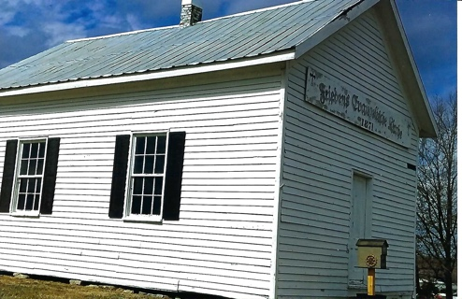
In the early 1870’s Mr. Jim Anderson and wife sold to the congregation for the sum of $1.00 a small tract of land, which is known as Anderson Hill, for the first church. Mr. Louis Meyer of Eagle Fork offered to supply the rough lumber for the building. The finishing lumber was hauled from St. Charles by team and wagon. The new church was Dautsche Friedens Evangelische Kirche, Friedens meaning peace.

The congregation attending services at the little church on Anderson Hill continued to grow. Soon it became apparent that a larger church must be built. Under the leadership of Rev. Schroedel, it was decided to construct the new building in the town of Moscow Mills. A deed to a plot of land for the new building dated June 1893 was secured from Moritz Bergfeld for the sum of $25.00. The cornerstone for the new building was laid August 12, 1893. The rough lumber for the building was again donated by Mr. Louis Meyer, and the bell by the parents of Mr. Wm. Munzel at a cost of $250.00. This bell was the first big church bell of the neighborhood. The toll bell, which has never been heard by some of our members, is still in the steeple. This bell was formerly used at funerals. Often it was tolled following a death to let the neighborhood know that a member had passed away. In German, the bell was called Das Tolane Clang. When the congregation moved to the new building it was decided to leave the little white church on Anderson Hill stand as a memorial to the founding of the congregation.

The new building in Moscow was much different than it is today. The basement was much smaller. The sanctuary was heated with two stoves. The minister had to climb a little stair to enter the high pulpit. One had to really look up to see the minister during the sermon. A tall-boxed off storage closet was in the northeast corner. This was removed. Today this is where the organ stands.

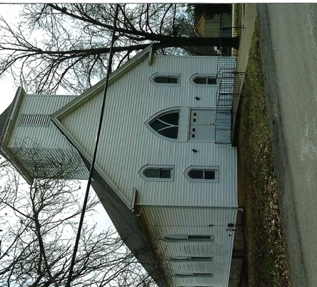
Using the two stoves to heat the sanctuary you either roasted or froze. The janitor received five dollars a year for taking care of the church. His chores included ringing the bell on Saturday evening, early Sunday morning, and before and after services. Funerals brought one dollar from the family of the deceased, half went to the church and half to the janitor.

Previous to 1920 all services had been delivered in German. In February of 1920 it was voted to have English services every other Sunday. Some time later all services were conducted in English.

In the 1930s the front of the church was remodeled. The high pulpit was removed and replaced with a much lower modern one. The steeple, which was much taller, was built lower; the steeple cross was erected on the lower steeple. The new steeple was donated by Pastor Brueseke’s father’s friend.

Our name was Evangelical church until in 1934 when we merged with the Reformed church and became Evangelical and Reformed (E&R). In 1957 we became the Friedens United Church of Christ.

For our 100th Anniversary, we installed new pews, new carpet and painted the interior. Between the spring of 1978 and the fall of 1979 we were in the process of securing a clear title to the present church property. A clear titled was recorded in the Lincoln County Recorder’s office on November 26, 1979.

Up until 1959 only adults could vote on church issues. After that, boys and girls were given the right to vote on church issues after being confirmed. After the 19th Amendment, women could vote. In 1969, Miss Charlotte Meyer was elected to the church council. This broke the tradition of German Protestantism.

In March of 1978 Friedens congregation broke ground for a Fellowship hall. On that day we honored our oldest member, Mrs. Louise Bergfeld, and our youngest, Eddie Wieman. This building was dedicated in August of 1978.

A quote from a letter written May 1978 states: “Sunday, April 30th, 1978, Zion United Church of Christ of Troy voted at a specially called congregational meeting to dissolve the yoke with Friedens United Church of Christ of Moscow Mills.”

In June 1979 Friedens congregation voted to build a parsonage on the lot donated to the church by Mr. and Mrs. A. C. Langford. In May of 1980 this parsonage was dedicated and on June 1, 1980 Pastor Allen and Reva Minor moved into our new parsonage to minister to the congregation. They served Friedens from 1980 to 1985. Then we were fortunate to hire Rev. John Riggs, who served until 1990. After Rev. Riggs moved to St. Louis, again we were blessed to have another excellent young man, Eugene Rahmier, serve us with his spiritual message and community service.

In 1981 red pew cushions, which were donated by a faithful member, added much to the comfort of those in attendance.

In 1983 the congregation voted to five the council permission to give the front of the chancel a “new face lift” by removing the cloth curtain and having a lighted arch installed. With the help of Mr. Dan Ricks of Winfield this improvement was dedicated in 1984.

In 1992 we gave the outside of the church and also the parsonage new life by covering both with white vinyl siding. At the same time the front steps were taken out and a ramp with black railing was installed.

A lady, Hilda Schulz, in our community and church family passed away in 2002. She left us a small amount of land and money to build a new church at her home. On May 21, 2006, we broke ground on this new brick church, and it was dedicated in August 2008. In this church we have a wonderful sanctuary, a cry room, office, restrooms and coat room, which is all a major improvement from the old church. A bonus was being able to have a basement with a full kitchen for church dinners and socials.

Our congregation has been very blessed through our rich 150 year history. We still have many of the same families’ descendants worshiping with us that started this congregation in 1871. We have a marvelous minister, Eugene Rahmier, who has community, church and family ties, that has held our congregation together and lead us through good and hard times.

God has truly blessed our small Friedens United Church of Christ congregation.

Written by Laura Helmich (1996) and Linda Sullivan (2021)

