Bethany-Peace United Church of Christ
Celebrating 50 Years
1971-2021
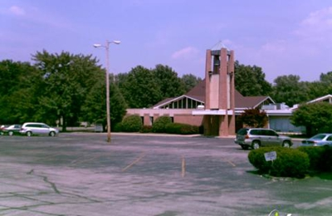

Bethany-Peace was created in 1971 as a merger of Bethany United Church of Christ and Peace United Church of Christ of St. Louis. The merged congregation continues at Peace’s location in Spanish Lake in north St. Louis County.
Bethany’s beginnings date back to 1867. They were also known as Deutsche Evangelische Bethania Gemeinde, Bethany German Evangelical Church, Bethany Evangelical Church, and Bethany Evangelical and Reformed Church. They have been in three different locations over the years. They were located at 22nd and Franklin in 1867 until 1874. They moved to 23rd and Cole in 1874 until 1915. In 1915 until their merger in 1971 with Peace UCC they were at Redbud and Rosalie.
Peace United Church of Christ was also known as Peace Evangelical and Reformed Church when they began in 1955. They merged with Bethany in 1971 to become Bethany-Peace United Church of Christ.

