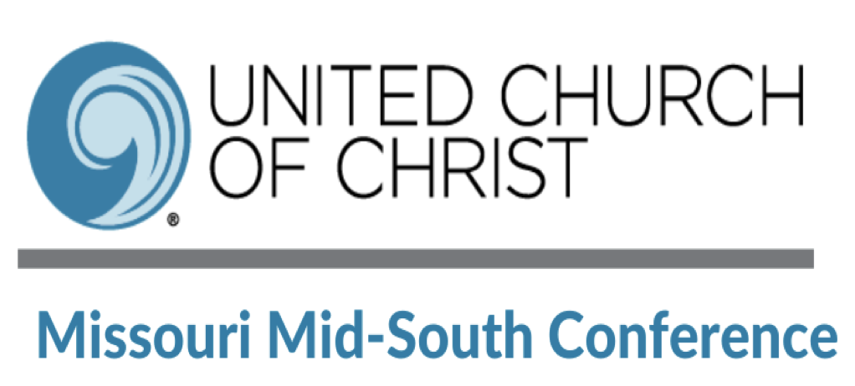

Conference Annual Gathering Opening Worship
Sunday, April 18th 6:30pm

Opening Music Rev. Eric Moeller, St. Peter’s UCC in Washington, MO

Welcome to CAG2021 Rev. Christi Tennyson, Pilgrim UCC, Labadie, MO

Let us Sing Together Rev. Eric Moeller, St. Peter’s UCC in Washington, MO
(Two Songs for Singing. Stay muted, but please sing along with us.)

Invitation to Worship Rev. Liz Deveney & Hank, the dog, Trinity UCC, Lexington, MO
We have come together as the lay members, the clergy and friends of the Missouri Mid-South Conference of the United Church of Christ to celebrate our faith in God. We bring all of ourselves today, body, mind, soul and heart to this service of worship in hopes that God will speak to us.

This time that we have been given by God is a blessing beyond our comprehension. Thus, we invite you to open your hearts to the endless possibilities that lie in our God. May our time together today also be a reminder of the many ways that we celebrate our beliefs through song, word and prayer.

Let us continue to be triumphant in this worship experience, knowing that God sees all things, and that through our faith in God we too shall one day come to know more of how God is Always at Work in All Ways in our world and beyond.

Passing the Peace Rev. Laura Mignerone, St. John UCC, St. Clair, MO
(Turn your mics and cameras on and say hello to one another.)

A Song of Response “O Love” Composed by Elaine Hagenberg
Performed by First Congregational of St. Louis Choir

A Special Reading “Ever New Things” Read by Alyssa Welch
Composed by Rev. Kristin Aardema Faigh, Zion UCC, Mayview, MO

Liturgical Dance Christ The King Dance Team Florissant, MO

A Sharing of Ancient Words Luke 5:33-39
Hannah Rice, First Congregational UCC, St. Louis

A Time for Reflection “Always & in All Ways” Rev. Damien J. Lake

Prayer of Reflection Rev. Meredith Jackson, Isaiah 58 Ministries, St. Louis, MO

Offering to the Conference Rev. Rob Van Ess, Holy Trinity UCC, Memphis, TN
Medical Debt Relief

Prayer of Thanksgiving Min. Kimberly McKenzie, Christ The King, Florissant, MO

Recognition of Significant Church and Clergy Anniversaries Rev. Ginny Brown Daniel

Today, we boldly proclaim the stories of those who have faithfully done God’s work, and have work yet to do; of congregations and clergy who have revealed, and are revealing, God’s Kin-dom in the here and now.

(congregations and clergy with significant anniversaries are named. After every name the gathered respond: With gratitude, we testify to their life-giving ministry.)

Bethany-Peace UCC has a 50-year anniversary of their merger –
(Bethany was originally founded in 1867 and Peace in 1955)
With gratitude, we testify to their life-giving ministry.

Two congregations will celebrate 150-year anniversaries:
Friedens UCC, Moscow Mills, MO
With gratitude, we testify to their life-giving ministry.
Ebenezer UCC, Ryors, MO (They call it Ryors Ebenezer UCC on Facebook.)
With gratitude, we testify to their life-giving ministry.

Four pastors are celebrating their 50th ordination anniversary:
Rev. Keith Karau
With gratitude, we testify to their life-giving ministry.
Rev. Robert Keller Jr.
With gratitude, we testify to their life-giving ministry.
Rev. Karl Kindt III
With gratitude, we testify to their life-giving ministry.
Rev. William Barney Kitchen
With gratitude, we testify to their life-giving ministry.

Breaking Bread Together Rev. Rushan Sinnduray, The Oasis UCC, Jefferson City, MO
Telling the story of Jesus gathering with the disciples.
A prayer before we eat.
All things are ready.

A Final Lifting of Voices through Song Jacob Nault, Eden Seminary Student, 2021
(Feel free to sing along as the Spirit inspires you)

Leading Worship Tonight

Rev. Dr. Ginny Brown Daniel - Conference Minister
Rev. Damien Lake - Associate Conference Minister
Rev. Eric Moeller, Musician and Associate Minister at St. Peter’s UCC in Washington, MO
Rev. Christi Tennyson, Minister at Pilgrim UCC in Labadie, MO
Rev. Rushan Sinnaduray, Minister at The Oasis UCC in Jefferson City, MO
Rev. Liz Deveney, Minister at Trinity UCC in Lexington, MO
Rev. Meredith Jackson, Hunger Program Director at Isaiah 58 Ministries, St. Louis, MO
Hannah Rice, Member at First Congregational UCC, St. Louis, MO
Rev. Laura Mignerone, Minister at St. John UCC, St. Clair, MO
Rev. Rob Van Ess, Minister at Holy Trinity UCC, Memphis, MO
Jacob Nault, Musician and Student at Eden Theological Seminary
Kimberly McKenzie, Member of Christ the King, Florissant, MO
Christ the King Dance Team

