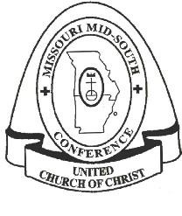
WESTERN ASSOCIATION
Missouri Mid-South Conference
United Church of Christ
483 East Lockwood Avenue, Suite 15; St. Louis, MO 63119

January 2021

Dear ministry partner,

Those of us who serve on the Committee on Ministry thank you for the service you give to the church of Jesus Christ and to the Western Association of the Missouri Mid-South Conference of the United Church of Christ.

As a fellowship of persons in ministry, ministers support one another and are accountable to each other. Mutual care and accountability take many forms; one of them is to identify yourself and your ministry by completing the 2021 Annual Clergy Informational Review (IR) form.

The IR form is completed once a year. It is the only way to “count noses” and be sure to have accurate contact information. The information you provide also helps our Conference keep their data base up to date, as well as the data hub in our Cleveland office. The IR may not seem important, but it is very important to all as UCC colleagues. Thus, it is a requirement for maintaining your good standing in the Association.

Please help us keep good records and support one another by completing the accompanying form and returning it by March 15, 2021. It’s easy to fill out on your computer and email to the Conference Office at kathleen@mmsucc.org. Or you may print the form and return it to Missouri Mid-South Conference UCC, 483 East Lockwood Avenue, Suite 15, St. Louis MO 63119. Because letters can get lost on our desks so easily when the due date is several weeks away, we suggest you complete it TODAY and return immediately.

We know the past year has been a difficult one and we hope you are doing well. Please reach out to the conference if you need any assistance. In this season of the new year, I hope the blessing of new life for you and your ministry.

Rev. Rick Oberle
The Committee on Ministry
Western Association

