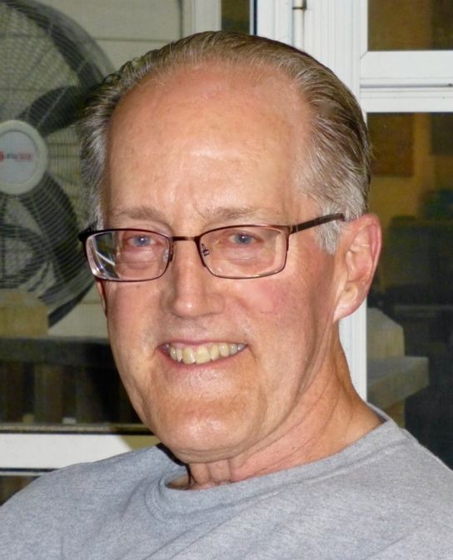

William Barney Kitchen
Celebrating 50 Years
Ordained 1971

Barney started life in El Paso,Texas during World War II. By age two he had relocated to Kansas City, Missouri where he spent the rest of his childhood. His family consisted of his father, a radiologist, his mother, a former school teacher, and three siblings.
He set off for the University of Kansas in 1960 and graduated from there with a degree in English. In 1965, he enlisted in the Army and in 1967 married Connie Young.
After three years in the US Army, he entered Chicago Theological Seminary and earned his Master of Divinity degree in 1971. He was ordained at the Union Church, UCC in Hinsdale, Illinois in July, 1971. From there, his first call was to the Federated Church in Fergus Falls, Minnesota where he was an Associate Minister in a UCC and Presbyterian linked congregation. It was a very rewarding three years spent in partnership with Senior Pastor Bill Van Dyken. Son Benjamin was added to the family there.
Next, there was a call to an Associate Minister position at the Peoples Church of Dover, Delaware. This was a new experience in the eastern part of the country and was most notable for the arrival of daughter Sarah. The family was now complete.
In 1976, Barney accepted a call from the Missouri Conference to be the founding pastor of a new church start in Blue Springs, Missouri. Through the usual trials and tribulations of a new church start, the Village UCC came into being and a new building was completed at the site of the Retired Ministers’ Homes in Blue Springs. Blue Springs is located close to Kansas City and the return to his home area provided special times with his parents and his brother’s family.
Six years later in 1982, the Missouri Conference again came calling — this time to the position of Associate Conference Minister for the Western Association. During Barney’s time serving the Western Association, many miles were traveled and many meetings took place as he aided churches in their search for pastors and gave aid to pastors in need of counsel. He enjoyed serving the Conference with colleagues Rueben Koehler, David Felton, Walter Snowa, and Barbara Greer.
The family home remained in Blue Springs during these years.
After eight years with the Missouri Conference, Barney accepted a call to return to the parish ministry and became Senior Pastor at Pilgrim Congregational UCC in St. Louis. Pilgrim is a significantly diverse congregation and the time there was highly rewarding for him. The time was the 1990’s and Pilgrim was finding its way to being Open and Affirming and Barney officiated at the congregation’s first same-gender covenants.
In 1998, Barney accepted a call to the Senior Pastor position at the First Church in Oberlin, Ohio. This historic church in a small college town was a sea change from the St Louis setting. The experience was challenging and the friendship of organist
Aymeric Dupré la Tour and Rev Susan Detterman were especially treasured. At the end of four years there, it was time to move on.
He finished his full-time career doing an interim pastorate for two years at the Amherst Community Church near Buffalo, New York. It was a beautiful area and the time there was a wonderful close to his full-time service. This warm and welcoming congregation is fondly remembered.
In 2004, he retired and returned to St Louis. Pulpit supply, a four month interim assignment as St Louis Association minister, and adult education opportunities constituted part time work for several years. He actively participated in the life of his home church, First Congregational of Webster Groves.
As a result of a stroke in 2017, his active involvement has been limited though he continues to work at his recovery. The stroke left him with memory issues but was much less damaging than it might have been. He feels fortunate to have come through as well as he did.
Barney lives with his wife, Connie, in Maryland Heights, Missouri and enjoys his daughter and her family which includes two grandsons also in St Louis. In addition, his son and his family are in Anchorage, Alaska with two additional grandsons. He enjoys spending time working out at the local YMCA with many good friends there.

