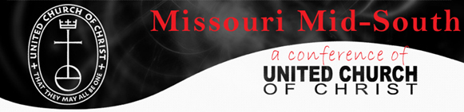

Missouri Mid-South UCC
Slate of Candidates

Synod Delegates Class of 2021-2023
 | Name |  |  |  | Association |  |  |  | Title
_____ | Nate |  | Fulk |  | Eastern |  |  |  | Clergy
_____ | Betsy |  | Happel |  |  | St. Louis |  |  |  | Clergy
_____ | Les |  | Kemp |  |  | Eastern |  |  |  | Layperson
_____ | Hannah |  | Rice |  |  | St. Louis |  |  |  | Layperson
_____ | James |  | Ross |  |  | St. Louis |  |  |  | Clergy
_____ | Jimmy |  | Watson |  |  | St. Louis |  |  |  | Clergy
_____ |  |  |  |  |  |  |  |  |  | Youth
Write In
____________________ ___________________ ____________________

Potential Alternates
Dick Kettenbrink (Eastern, Lay),
Sue Leicht (Eastern, lay)
Alysha Petry (Eastern, lay)
Rev. Andrew Lovins (Eastern, clergy)

This page is to be used as a ballot if nominations are made from the voting floor. Otherwise, nominees are voted as an entire slate.

The above slate was approved by the Conference Council, pursuant to the Bylaws of the Missouri Mid-South Conference of the United Church of Christ, Article III, Nominations and Elections.

