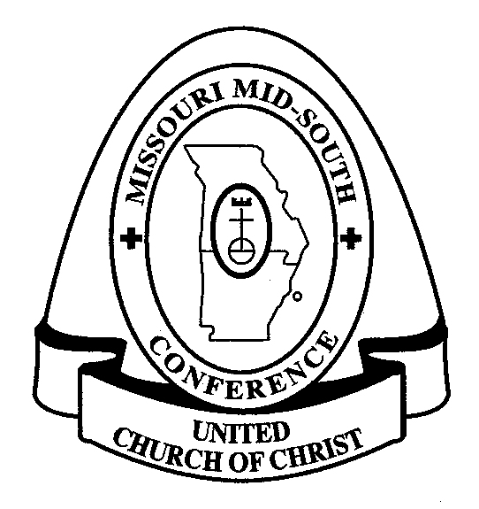
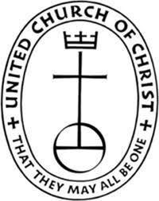
Missouri Mid-South Conference UCC
483 E. Lockwood Avenue, Ste. 15
St. Louis, MO 63119
314-962-8740 • 877-877-5884
accounting@mmsucc.org

2016 Commitment to Basic Support/OCWM Form

This form may be completed on your computer

Church Name:

Church Street Address:

City/State/Zip:

2016 Commitment Amount: $

Form Completed by/Title:

Daytime Phone Number:

Email Address:

Date:

Once completed, please save this document for your church records.
- You may then email your completed form to our Conference Bookkeeper, Lorraine Brooks, at accounting@mmsucc.org.
- You may also print the form and fax to our Conference office: 314-918-2610.
- Print and snail mail to: Missouri Mid-South Conference
483 E. Lockwood Ave, Ste. 15
St. Louis, MO 63119

Thank you for your assistance with managing the financial resources of
the Missouri Mid-South Conference

