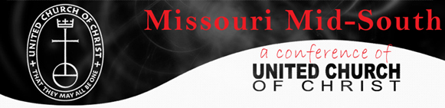
Conference Council Member Commitment Agreement
I, ______________________________ understand as a member of the Conference Council (the Board of Directors) of the Missouri Mid-South Conference of the United Church of Christ (“the Conference”), I have a legal and ethical responsibility to ensure the Conference does the best work possible in pursuit of its goals. I believe in the purpose and the mission of the Conference, and I will act responsibly and prudently as its steward. My behavior as a member will be consistent with the values and mission of the Conference.
As part of my responsibilities as a Conference Council member:
- I will interpret the Conference's work and values to the community, represent the Conference, and act as an ambassador.
- I will regularly attend and come prepared (reading and reviewing material previously sent) to conference council meetings, committee/covenanted ministry meetings, the Conference Annual Gathering, and special events. I will RSVP my attendance to Conference Council meetings or committee/covenanted ministry meetings at least one day in advance to the Moderator or the respective chair.
- Each year I will make a personal financial contribution directly to the Conference at a level that is meaningful to me and I will participate in other Conference and United Church of Christ fundraising events as I am able.
- I will act in the best interests of the Conference, and excuse myself from discussions and votes where I have a conflict of interest.
- I will stay informed about what's going on in the Conference and any committee/ covenanted ministry team I serve. I will ask questions and request information, and will participate in and take responsibility for making decisions on issues, policies and other board matters.
- I will work in good faith with the Conference Minister, staff and other Conference Council/ministry members as partners towards achievement of our goals.
- If I don't fulfill these commitments to the organization, I will expect the Moderator to call and discuss my responsibilities with me.

In turn, the Conference will be responsible to me in several ways:
- I will be sent regular financial reports and updates of Conference activities including the Conference’s programs, goals, activities, and status reports.
- The Conference will help me perform my duties by keeping me informed about issues and challenges in the Conference and the United Church of Christ.
- The Conference Council, Conference Minister and staff will work in good faith with me towards achievement of our goals.
- If the Conference does not fulfill its commitments to me, I can call on the Moderator and Conference Minister to discuss the Conference's responsibilities to me.
Signed:____________________________________ Member Date: _______________
Signed:__________________________________ Moderator Date: _______________
The Moderator should sign two copies of this agreement for each board member. Each new board member should sign both, return one copy to the Moderator, and keep the other for reference

