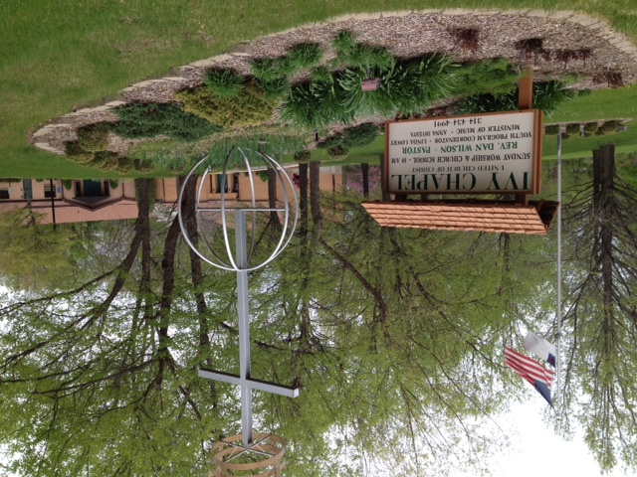
Ivy Chapel United Church of Christ has a unique and fascinating history. The congregation has roots in the Swedenborgian Church (or New Church, or Society of the New Jerusalem) which bases its faith on the theological beliefs of Emanuel Swedenborg (1688-1772), a Swedish scientist and theologian.
The first Swedenborgian Church in Saint Louis, Missouri was established (circa 1850) near the intersection of 6th Street and Saint Charles Street. By the mid-20th century, this congregation was declining in membership size and their location had become industrialized. In 1958, the Saint Louis congregation sold their church building in the city and moved to Creve Coeur, Missouri. A sanctuary of exquisitely beautiful architecture was built at 1045 Dautel Lane. In May 1959, the new building was dedicated and named Garden Chapel Community Church.
In the early 1960’s, dissension occurred within Garden Chapel Community Church. As a result, some church members, including Rev. Ellsworth Ewing, left the Creve Coeur location and began a new congregation. For a time, this fledgling congregation met at 718 Creve Coeur Plaza. The congregation was incorporated under the name Ivy Chapel by the State of Missouri on April 27, 1964. Ivy Chapel petitioned the Missouri Conference to become a participating congregation in the United Church of Christ. This request was approved on May 13, 1964 at the annual meeting of the Missouri Conference of the United Church of Christ. In October 1964, the congregation changed locations and began meeting at the Robinwood Swim Club located at 12556 Merrick Drive in Creve Coeur.
The congregation received a grant from the United Church Board for Homeland Ministries to purchase property and to construct a building. In February 1965, six acres of land was purchased, located on Highway 141 south of Olive Street Road in Chesterfield, Missouri. On this site, at the street address 620 North Woods Mill Road; a simple, rectangular structure (a Butler Building) was constructed.
Sunday, November 14, 1965, the formal dedication of Ivy Chapel United Church of Christ was celebrated with a special afternoon worship service.
Groundbreaking occurred in 1974 for a new sanctuary and a Christian education facility. These additions to the church building were dedicated on Sunday, January 26, 1975 at a special afternoon worship service.
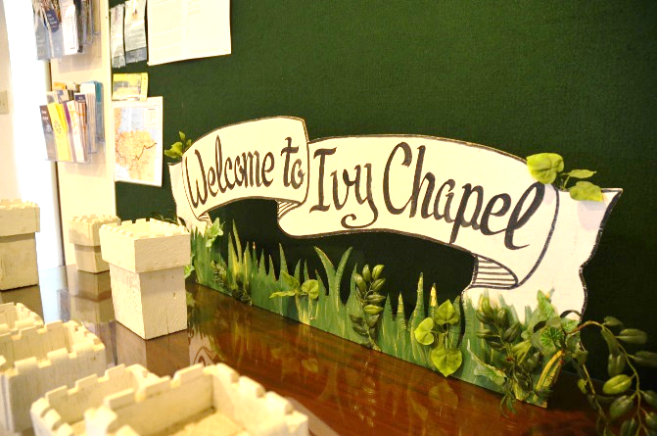
In 1984, the congregation embarked on another building project. This work included the renovation of a portion of the original 1965 structure and the addition of a new area (church office, Christian education office, nursery, multi-purpose room, pastor’s study). This project was completed in 1985.
D-18
Ivy Chapel United Church of Christ is holy ground. In 2014, the congregation’s golden anniversary year; God’s people celebrate one half century of ministry lovingly offered here. Caring acts of discipleship are yet to unfold through the faithfulness of this community of God, which many affectionately call “Ivy.” God is alive in the vibrant ministries of Ivy Chapel United Church of Christ.

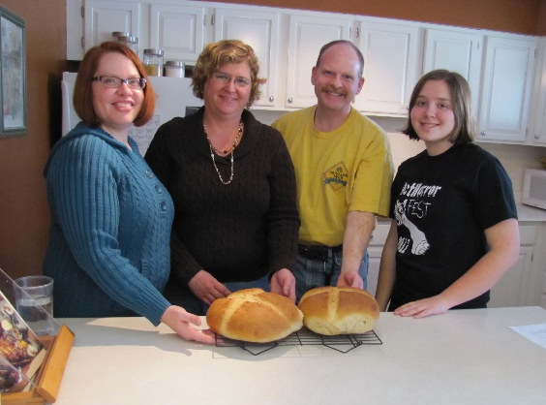

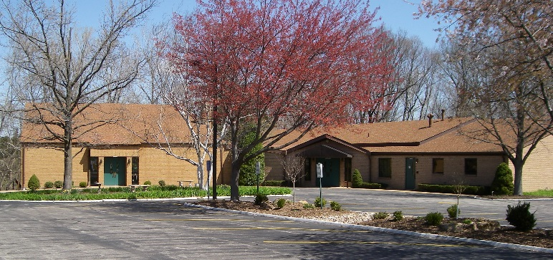

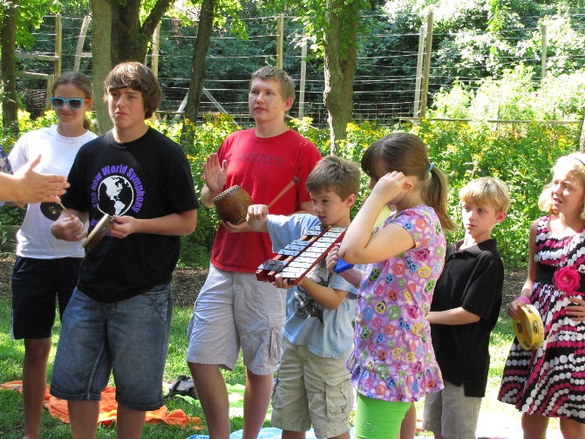
D-19
