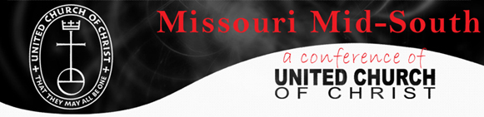

Missouri Mid-South UCC
Slate of Candidates for Conference Council

Class of 2020
 | Name |  |  |  | Association |  |  | Title |  |  |  | Term
_____ | Cheryl |  |  | Howard |  | Eastern |  |  |  | Layperson |  |  | 2
_____ | Les |  |  | Kemp |  |  | Eastern |  |  |  | Layperson |  | 1
_____ | Betsy |  |  | Reznicek |  |  | St. Louis |  |  |  | Layperson |  | 1
_____ | Donna |  |  | Smith-Pupillo |  |  | St. Louis |  |  |  | Clergy |  | 2
_____ | Bill |  |  | Biedenstein |  |  | St. Louis |  |  |  | Layperson |  | 1
_____ | David |  |  | Rauch |  |  | Western |  |  |  | Layperson |  | 2
_____ | Chase |  |  | Peeples |  |  | Western |  |  |  | Clergy |  | 2
_____ | Judith |  |  | Bartell |  |  | Western |  |  |  | Laywoman |  | 1
_______ ________________________ ________ ______________
Name Association Title

This page is to be used as a ballot if nominations are made from the voting floor. Otherwise, nominees are voted as an entire slate.

The above slate was approved, pursuant to the Bylaws of the Missouri Mid-South Conference of the United Church of Christ.

